Ecliptic Harpoon:   
Mapping the Moon's Dunes

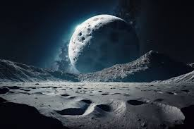

Authors:

Rasmus Jacobsson  
Sebastian Magnusson  
Joel Ottosson Fridlund  
Petter Sjaunja  
Albin Ringström

Contents

1. Mission scenario 1

2. Mission assumptions 1

# Mission scenario

Moon orbit, imaging/mapping of surface. Fnhwefwiufvjwf

Hejsan waka waka

# Mission assumption